# MEGAeBin Content (more…)

## Secure:

We 100% guarantee that your files and personal information stay safe, no matter what. Edit files and share documents, photos & videos with anyone you choose. Encryption capabilities ensure protected operation at all times.

## Convenient:

Collaborate on files and share entire folders with friends, family or co-workers from any device. Wherever you are, access what you need.

## Reliability:

Save & manage your files freely with the assurance of the stable and responsive functionality of MEGAeBin software. Files are never lost in the cloud-based software and are retained each and every time.

## **Business:**

**MEGAeBin Ensures You Get More from Your Business**

A business may have one main location, but its operation is not stationary. Cloud capability has shaped the business world with the right tools of versatility and accessibility. MEGAeBin makes being ‘In-The-Cloud’ that much easier! Having access to your important information at all times is an imperative need for businesses

Collaborate ideas, documents and media files with colleagues from any device and any location. MEGAeBin offers online storage that is safe and secure, allows team members to sync and share data from all devices.

* Your data access is seamless and we promise to protect your information both inside and outside the organization.
* Foolproof & handy from home, office and on-the-go
* Information is always on-demand
* Increased productivity for the entire team
* Cloud-based system that supports all Microsoft, Apple and Linux files.

**We Aim & Achieve Securing Data and Company Information**

Safeguarding your business data is our top priority and a company-wide promise from Virtual Stacks Systems™. Maintaining control over information flow can be very difficult when it comes to utilizing a system that stores data. This is NOT the case with MEGAeBin. One of the greatest benefits to your business is the System Administrator Control that allows you to monitor who can share, view and edit which files. Plus, the user-friendly interface allows you to restrict access and secure data in the event a device is lost or pilfered.

**MEGAeBin is the Right Choice for Your Business**

Eliminate the frustration of misplacing or even losing important documents by taking the steps to becoming a paperless organization. Perks like device permissions management, unlimited file recovery and distributing assignment capability each make MEGAeBin the best choice for your company.

* Improve your organization’s environmental footprint by reducing hardcopy waste
* Cut costs with the affordably low business aid
* Even use MEGAeBin as a backup to reduce media clutter on your hard drive

## **HELP: FAQs**

**What exactly is MEGAeBin?**

MEGAeBin is a cloud-based file sharing and storage system of top notch applications that promise 24/7/365 protection, uptime and accessibility.

**How can MEGAeBin benefit my Business?**

There are many great benefits for business operations. The key benefits MEGAeBin brings any business include safely encrypted security measures, sharing of any type of file, and reliable storage space. Plus the accessibility alone is impressive as it increases efficiency and user satisfaction. See our [MEGAeBin for Business page](https://mail.google.com/mail/u/0/?tab=wm#inboxhttp://megaebin.com/pages/?pid=business) to learn about more great perks!

**I’m ready to get started, what should I do first?**

First, welcome and thank you for joining the Virtual Stacks™ family! Start by choosing the plan that meets all of your needs and create an account. It’s that simple.

You have the choice to visit the site and start downloading files right away (best for personal use to share with family and friends). Or you can download and install MEGAeBin to your computer for even more security (Best for businesses and highly protected data). Contact us for help choosing the best option for you.

**I’ve signed up, now what should I do?**

Welcome MEGAeBin rookie! Click on **My Account** and fill in your account information and personalize your profile. Create a *New Folder* for optimal organization. Now simply start uploading files and choose who you want them shared with!

**How many users can I share my account with?**

As many as you want; user count is unlimited!

**Are any files prohibited from MEGAeBin?**

Any file over a size of 20MB will not download.

**How often are backups?**

Thanks to the Virtual Stacks Systems™ backup infrastructure, your files are saved to more than one storage datacenter to eliminate the loss of files or interruptions to uptime and business operation flow.

**How do I move past MEGAeBin user files to a current user?**

In the *File Manager* section, select the folder you want moved and click the Drop-Down arrow action button at the end of the listed Folder. Select Move and enter where it should be moved to.

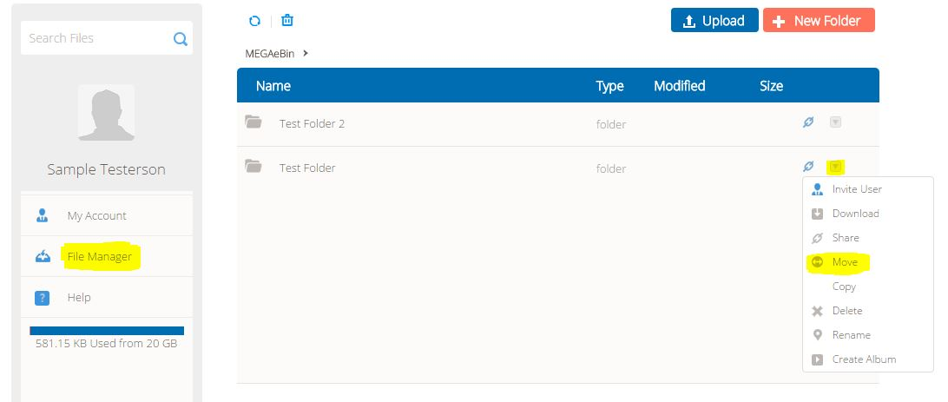

**What can I share with other users?**

Windows, iOS and Linux files can all be uploaded and shared in MEGAeBin. You can share both files and entire folders and in turn have either option shared to you.

**Why is sharing files via MEGAeBin so necessary?**

It’s simple really; security. Protect your content, media and all important files externally with storage options that offer more than a place to put files. The reliability of MEGAeBin storage is just as valuable and trusted.